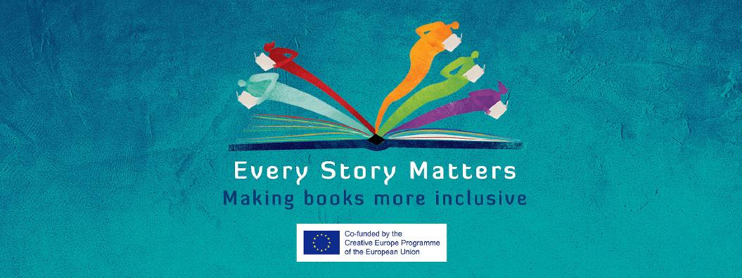
I want to pitch an inclusive book

Hi there!
Great you want to take part in the online B2B of Every Story Matters.
By participating you can 1) send in a video or text to pitch an inclusive book and/or
2) send in a profile of your publishing company to acquire new titles.
All of the pitches and profiles are uploaded on the Every Story Matters website for you and others to explore. Don’t hesitate to contact any publisher you’d like to exchange with!
By inclusive we mean books in which the plot, the characters, the illustrations, etc. feature diverse socio-economic or cultural background, gender, sexual preference or mental and physical (dis)abilities. By inclusive we mean literature that reflects and honors all readers regardless of their differences, whatever those may be.
Each company can send in a maximum of three pitches (i.e. three books that can be pitched per company) plus a maximum of two profiles (e.g. one for picture books and one for novels, or one for fiction and one for nonfiction) . If you wish to upload multiple videos, please copy the relevant forms.

How do I participate?
Please fill out this form for every pitch you wish to upload. You can copy the form if necessary.
If you want to present your publishing house you can fill in a separate form, available here.
Record a video (no longer than 1:10 minutes) or write a text to pitch your inclusive book title. Please film your video in landscape view (horizontally) and save in .mp4, .mov or .avi format.
Don’t forget to send in the cover of the inclusive book you are pitching, as well as any sample illustrations if available (.jpg or similar format). Add any attachments or additional information if relevant (sample translations, news articles…).
Send us your text(s)/video(s) together with your filled in form(s) and possible attachments (illustrations, sample translations…) through WeTransfer to b2b@everystorymatters.eu.

Do you experience any trouble filling in this form or filing the application? We’re glad to help you on b2b@everystorymatters.eu.

Details of the applicant:

Company name:
Website (www):
Country:
Language:
Name:
Mail:

Information on the inclusive book I’m pitching:

Title of the book in English:
Original title of the book:
Original language:
The book I’m proposing is for these age groups: | ☐ 0-4  ☐ 5-7  ☐ 8-12  ☐ 13-16  ☐ 16+
The book I’m proposing is in these categories: | ☐fiction  ☐ nonfiction  ☐ illustrated  ☐ wordless
The book I’m proposing is inclusive towards: | ☐ gender  ☐ race  ☐ sexuality  ☐ ability  ☐ socio-economic background  ☐ migrations  ☐ cultural background  ☐ others: ...
Author’s name:
Illustrator’s name:
Number of pages:
Format (in mm):
Year of first publication:
Rights holder:
Email rights manager:
Info on sold and/or available rights:
Available (sample) translation(s): | ☐ no  ☐ yes, in the following languages: …
Book description/summary:
Biography from the author:
Biography from the illustrator:
Sales numbers (if they are high for your book market):
Awards and nominations:
Links to media mentions (preferably in English):
Description of your publishing house:

Thank you!

