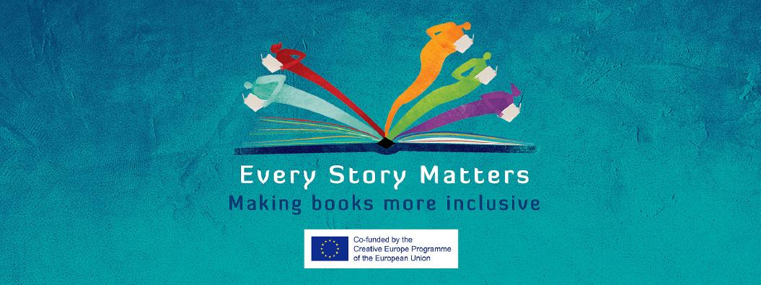
I want to present my publishing company

Hi there!
Great you want to take part in the online B2B of Every Story Matters.
By participating you can 1) send in a video or text to pitch an inclusive book and/or
2) send in a profile of your publishing company to acquire new titles.
All of the pitches and profiles are uploaded on the Every Story Matters website for your and others to explore. Don’t hesitate to contact any publisher you’d like to exchange with!
By inclusive we mean books in which the plot, the characters, the illustrations, etc. feature diverse socio-economic or cultural background, gender, sexual preference or mental and physical (dis)abilities. By inclusive we mean literature that reflects and honors all readers regardless of their differences, whatever those may be.
Each company can send in a maximum of three pitches (i.e. three books that can be pitched per company) plus a maximum of two profiles (e.g. one for picture books and one for novels, or one for fiction and one for nonfiction) . If you wish to upload multiple videos, please copy the relevant forms.
How do I participate?
Please fill out this form for every department from your publishing house (e.g. fiction, non-fiction, picture books,...) you wish to present. You can copy the form if necessary.
If you want to pitch inclusive stories you can fill in a separate form, available here.
Record a video (no longer than 1:10 minutes) or write a text to present your publishing house/department. Please film your video in landscape view (horizontally) and save in .mp4, .mov or .avi format.
Don’t forget to send in the logo of your publishing house (.jpg or similar format).

Send us your text(s)/video(s) together with your filled in form(s) through WeTransfer to b2b@everystorymatters.eu.

Do you experience any trouble filling in this form or filing the application? We’re glad to help you on b2b@everystorymatters.eu.

Details of the applicant:

Company name:
Website (www):
Country:
Language:
Name:
Mail:

Information on the publishing house I’m presenting:

Write down approximately 10 sentences on your publishing house and your program:

I’m interested in acquiring the following stories:
Age groups:
☐ 0-4
☐ 5-7
☐ 8-12
☐ 13-16
☐ 16+

These categories:
☐ fiction
☐ nonfiction
☐ illustrated
☐ wordless

Inclusive towards:
☐ gender
☐ race
☐ sexuality
☐ ability
☐ socio-economic background
☐ migrations
☐ cultural background
☐others

If you are looking for anything else that is not mentioned above, please describe it in a maximum of 30 words:

